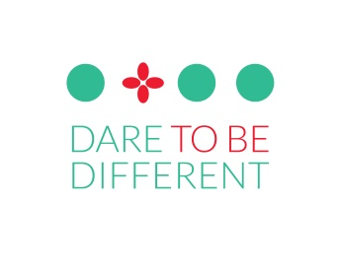
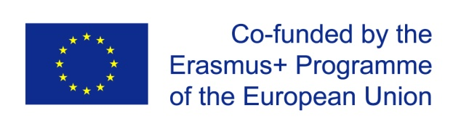
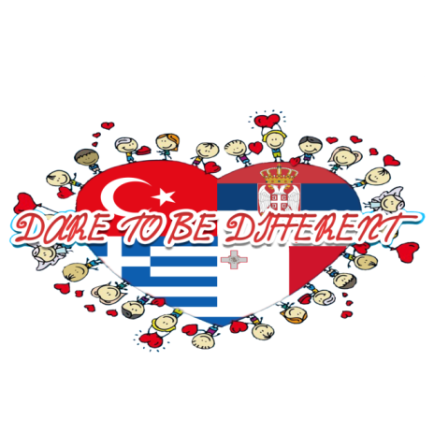

Title
Erasmus+ KA 201 project
DARE TO BE DIFFERENT –
CREATIVE DRAMA IN EDUCATION
ERASMUS+ KEY ACTION 2
STRATEGIC PARTNERSHIP FOR INNOVATIONS

Description of project
In the perspective of the 21st students' needs and market, the educational paradigm has changed and still has to change a lot. Education is challenged to foster and build competences of teachers and students. Among the key EU competences Creative Drama caters for the majority of them i.e. literacy and languages; personal, social and learning competences; civic competences, cultural awareness and expression, as well as the digital competence.
The objectives of our project are to develop creative and critical thinking of students, to raise the level of motivation and satisfaction with learning processes, to enable students to tackle different issues in a constructive and creative way, and to foster respect for diversity.
The participants who will directly be involved in the project through different activities of implementation and dissemination of project results will be teachers and students and drama pedagogues of five partner organisations (app. 1600 persons).
The main activities performed during the period of 22 months are creative drama processes implemented in regular classes of different subjects: apart from mother tongue, those are English language, Biology, History, Science, Maths, Social studies, etc.
Along with applying drama techniques in lessons, creative drama process will be fostered in thee extra-curricular Drama Clubs where students will be led through a process drama in order to deal creatively and critically with different issues that tackle their lives: school violence, accepting diversity, healthy lifestyle, Internet safety, environmental problems, inclusion, interculturality and other topics of interest to the partner schools.
Partners
- Zabbar Primary B, Malta
- Esenkoy Adnan Kaptan Ortaokulu, Turkey
- Demenika Primary School, Greece
- BAZAART, Belgrade, Serbia

Benefits of creative drama
- Development of language and communication skills
- Problem solving practice
- Creativity
- Positive self-concept
- Empathy
- Social awareness
- Values and attitudes
- The process happens in the safe environment.

The most important results
- Two books:
- 1) Bunch of colourful activities (lessons delivered by using drama techniques in different subjects)
- 2) Dare To Be Different (plays created through creative drama processes with students in Drama Club meetings and regular classes)
Four original scripts created by students:

Outcomes
- Adopted and applied dramatic expression and improvisation in learning to develop creativity, critical thinking and functional knowledge,
- Developed intercultural skills,
- Raised level of understanding and acceptance of other cultures,
- Raised level of knowledge and use of English,
- Established contacts and friendships for further cooperation in eTwinning and Erasmus projects,
- Developed team and peer education in an international environment.

